Computer Vision - Week 2 - Image Segmentation

Prof. Xujiong Ye – Medical imaging domain, animal tracking, behaviour analysis, early disease detection, surveillance system

03/03/2022

**Image segmentation** – the process of partitioning a digital image into multiple regions/ segments that represent objects or meaningful parts of objects.

**Matlab Definition** - Image segmentation is a commonly used technique in digital image processing and analysis to partition an image into multiple parts or regions, often based on the characteristics of the pixels in the image. Image segmentation could involve separating foreground from background, or clustering regions of pixels based on similarities in colour or shape. For example, a common application of image segmentation in medical imaging is to detect and label pixels in an image or voxels of a 3D volume that represent a [tumor in a patient’s brain](https://uk.mathworks.com/help/deeplearning/ug/segment-3d-brain-tumor-using-deep-learning.html) or other organs.

**Uses of Image Segmentation**

Several algorithms and techniques for image segmentation have been developed over the years using domain-specific knowledge to effectively solve segmentation problems in that specific application area.  These applications include medical imaging, automated driving, video surveillance, and machine vision.

**Medical Imaging**

An Image segmentation technique called clustering is used to identify distinguished tissue types in medical images. These tissues can be marked prior with strainers such as haematoxylin and eosin (H&E). Clustering is a method to separate groups of objects in a scene. The K-means clustering algorithm finds separations such that objects within each cluster are as close to each other as possible, and as far from other objects in other clusters as possible.

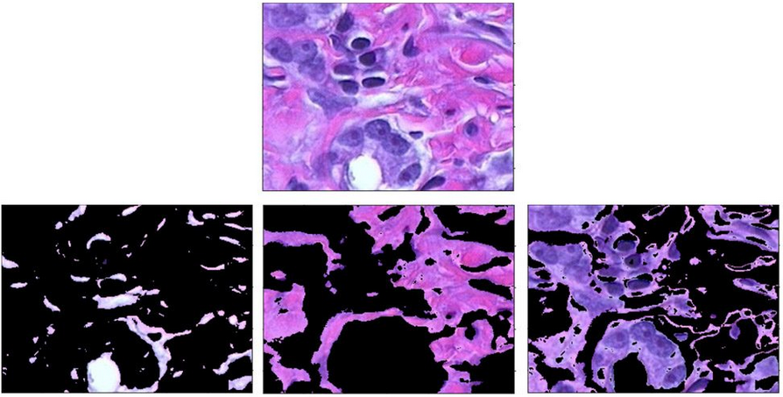

Using clustering to distinguish between tissue types (bottom) in an image of body tissue (top) stained with haematoxylin and eosin (H&E).

**Autonomous Driving**

Semantic segmentation is popularly used when designing perception for autonomous vehicles such as self-driving cars, it helps systems identify and locate vehicles and other objects on the road.

**How image Segmentation Works**

Image segmentation involves converting an image into a collection of regions of pixels that are represented by a mask or a labelled image. By dividing an image into segments, you can process only the important segments of the image (that belong to a particular class) instead of processing the entire image. A common technique is to look for abrupt discontinuities in pixel values, which typically indicate edges that define a region.

**Image Filtering in the Spatial Domain**

Filtering is a technique for modifying or enhancing an image. For example, you can filter an image to emphasize certain features or remove other features. Image processing operations implemented with filtering include smoothing, sharpening and edge enhancement.

Filtering is a neighbouring operation, in which the value of any given pixel in the output image is determined by applying some algorithm to the values of the pixels in the neighbourhood of the corresponding input pixel. A pixel’s neighbourhood is some set of pixels, defined by their locations relative to that pixel. Linear filtering is filtering in which the value of an output pixel is a linear combination of the values of the pixels in the input pixel’s neighbourhood.

**Convolution**

Linear filtering of an image is accomplished through an operation called convolution. Convolution is a neighbourhood operation in which each output pixel is the weighted sum of neighbouring input pixels. The matrix of weights is called the convolution kernel, also known as the filter. A convolution kernel is a correlation kernel that has been rotated 180 degrees.

Another common approach is to detect similarities in the regions of an image. Some techniques that follow this approach are region growing, clustering and thresholding.

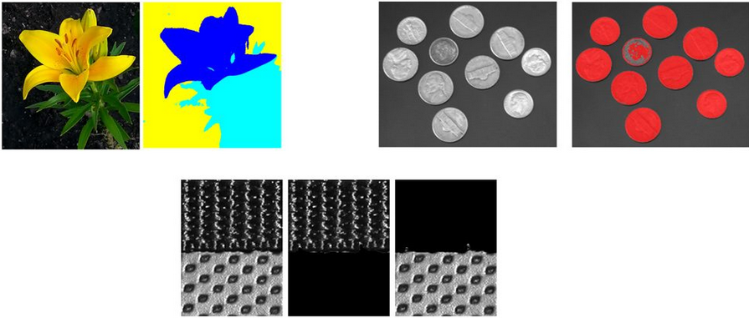

Segmenting regions based on color values, shapes or texture.

A variety of other approaches to perform image segmentation have been developed over the years using domain specific knowledge to effectively solve segmentation problems in specific application areas.

Common Approaches to Segmentation:

* Edge-based method
* Region-based method

Other approaches:

* K-means, mean shift
* Energy minimization
* Deep learning

**Edge Detection**

Edges correspond to large changes in intensity of neighbours pixels in at least one direction

Prewitt and Sobel are implementations of first order derivitate edge detection, in Sobel two masks are also used Gx and Gy but instead of using 1s and -1s, 1s and 2s are used to show significance of the pixel.

Laplacian is an implementation of a second order derivative of dege detection

Difference between first and second order, the second other provides thinner edges and better responds to fine details.

Noise removal: it is necessary to remove noise with derivative based methods because they are very sensitive to image noise. Therefore, you typically smooth an image to try to remove the noise before we apply edge detection.

One method of smooth is the Gaussian Filter. It is a standard smoothing method. The bigger the standard deviation used, the smoother an image would be. This can could be a reason for too much smoothing, resulting in images that are not sharp enough for edge detection.

Because edge detection is a convolution process, for each pixel we look at pixels along an area, therefore they take local measurements

What other methods of edge detection are there besides derivate based methods?

Advanced Boundary Detection

This not lonely looks at intensity, it also looks at other features such as texture and combines them together into one framework to form an edge group.

Boundary Detection

For every pixel in the image, we draw a circular disc and the radius of the disk is split into half along 6 directions. Calculate the three scales for the regions. The size of the disk and multiple scales are also considered along with multiple orientations.

Region Based Segmentation

Unlike edge-based region directly tries to detect regions

Active Contour Models(snake)

Edged based and region don’t work when dealing with objects of actively changing shapes such as live cells

It looks for any shape in the image that is smooth and forms a closed contour.

This becomes an optimisation problem

In order to find an object boundary, we initialise our curve close to the object boundary and then shape the curve to fit the shape of the object.

Modelling

Internal energy function. This does not relate to the image, they simply try to make the curve smooth. You want the minimal energy, the minimal derivative produces a smooth curve. The smoother a curve, the closer the fit would be to the object.

external energy function is derived from the image. It tries to push the image boundary towards the object boundary to make the curve fit the object.

K-means segmentation

The problem with this is that it can often get stuck in a local minimum

Mean shift segmentation

With mean shift you do not need to define the number of K clusters, this is automatically done.

References:

MATLAB. What is Image Segmentation? Available at: <https://uk.mathworks.com/discovery/image-segmentation.html> [Accessed: 25/03/2022]